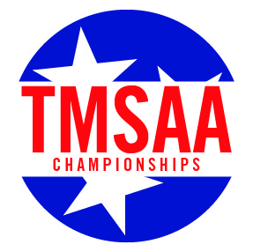
TMSAA Sectional Basketball Tournament
Team Pass List
Section 4 – Hosted by Collierville Schools

School Name
Boys or Girls

Administrators, Coaches, Players, Managers, and Cheerleaders do not need to be listed

Name of Guest | # of Ticket Requested

