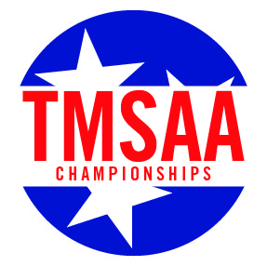
TMSAA Sectional Basketball Tournament
Hospitality List
Section 4 – Hosted by Collierville Schools

Administrators and Coaches Only

School Name
Boys or Girls

Name | Title

